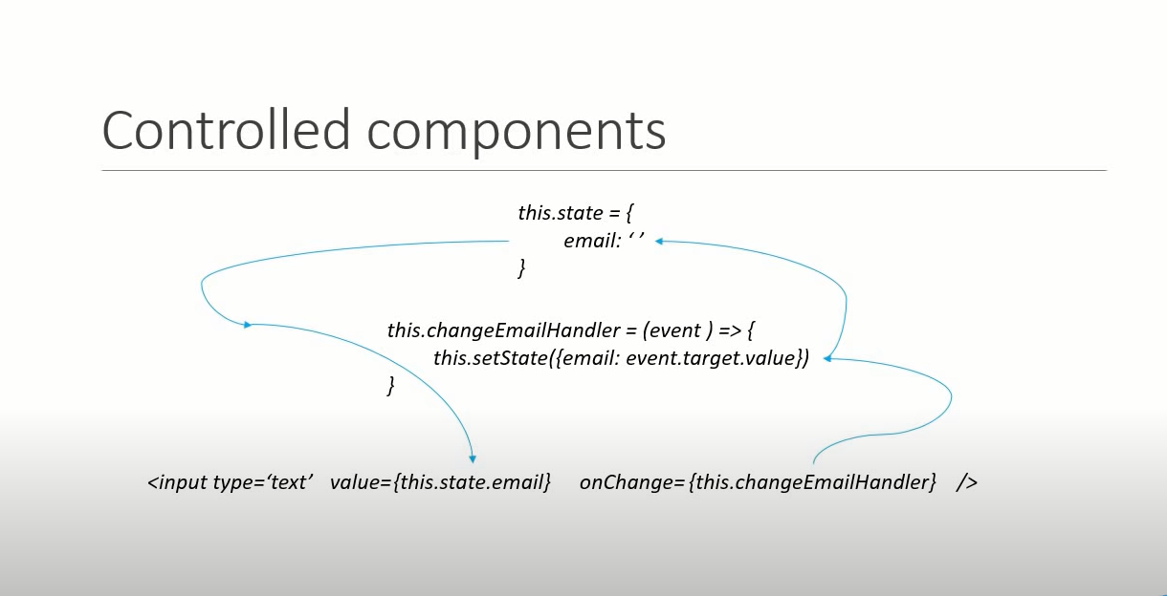

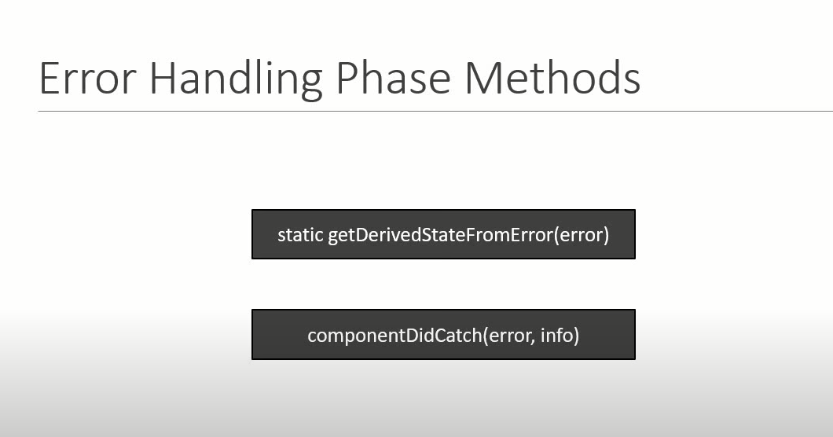

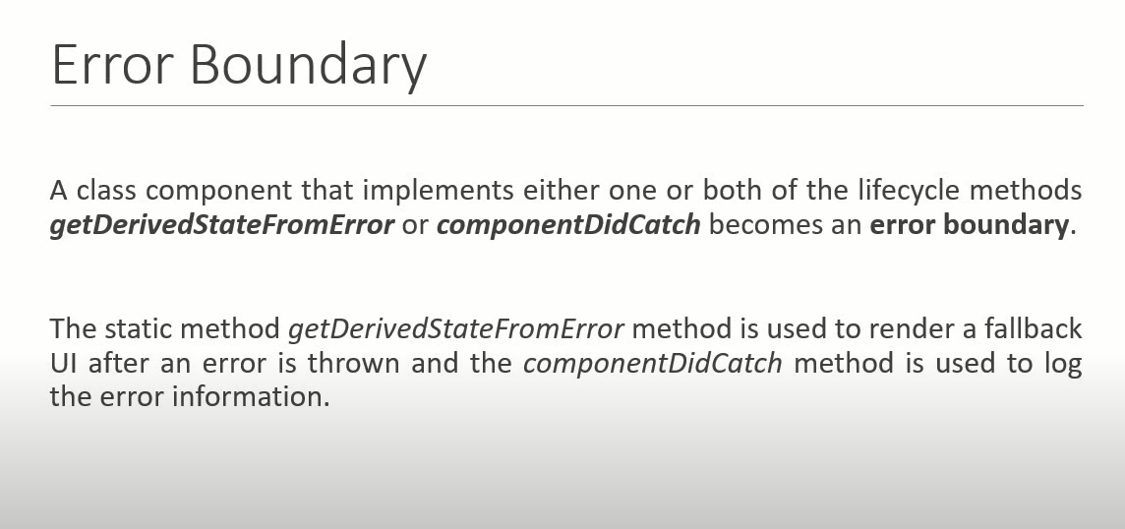

import React, { Component } from 'react'

class Form extends Component {

  constructor(props) {

    super(props)

    this.state = {

        username:'',

        comments:'',

        topic:'react'

    }

  }

  handleUsernameChange = (event) =>{

//if u changing event you can capture

this.setState({

  username: event.target.value

})

  }

  handleCommentChange = (event) =>{

    //if u changing event you can capture

    this.setState({

      comments : event.target.value

    })

      }

      handleTopicChange = (event) =>{

        //if u changing event you can capture

        this.setState({

          topic : event.target.value

        })

          }

          handleSubmit = (event) =>{

           alert(`${this.state.username} ${this.state.comments} ${this.state.topic}`)

           event.preventDefault()

              }

  render() {

    return (

      <form onSubmit={this.handleSubmit}>

        <div>

        <label>Username</label>

            <input type='text' value={this.state.username} onChange={this.handleUsernameChange}/>

        </div>

        <div>

        <label>Comments</label>

            <textarea value={this.state.comments} onChange={this.handleCommentChange}/>

        </div>

        <div>

        <label>Topic</label>

            <select value={this.state.topic} onChange={this.handleTopicChange}>

              <option value="react">React</option>

              <option value="angular">Angular</option>

              <option value="vue">Vue</option>

            </select>

        </div>

<button>Submit</button>

      </form>

    )

  }

}

export default Form